Architecture Views

1. Introduction
This document provides a structured approach for documenting architecture views in compliance with the FDA's guidance on cybersecurity in medical devices. Architecture views help define the security design and structure of a medical device system, ensuring its resilience against cyber threats.

2. Purpose and Scope
Describe the purpose of architecture views in the context of medical device security. Define the scope of architectural representations, including hardware, software, network, and data flow considerations.

3. System Architecture Overview
Provide a high-level overview of the medical device system, including its key components, connectivity, and data flows. Include diagrams where applicable.

4. Security Architecture Views
The following architecture views should be documented to illustrate the security design of the medical device:

4.1 Hardware Architecture
Describe the hardware components of the medical device, including:
- Processing units and memory
- Hardware security modules (HSMs)
- Secure boot mechanisms
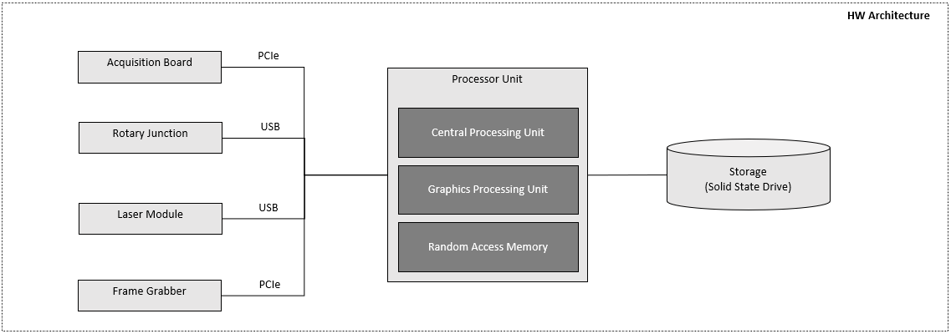

4.2 Software Architecture
Provide an overview of the software components, including:
- Operating system and firmware details
- Application software modules
- Software security controls and enforcement mechanisms
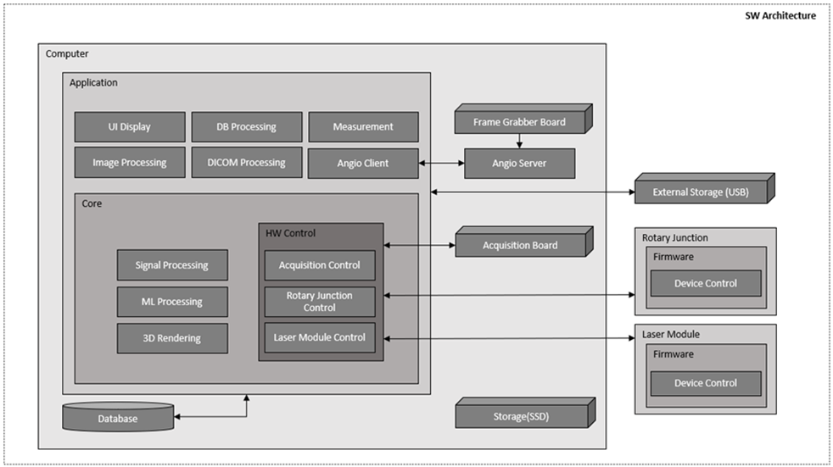

4.3 Network Architecture
Describe how the device connects to other systems and networks, including:
- Communication protocols and encryption standards
- Firewall and intrusion detection mechanisms
- Secure data transmission paths
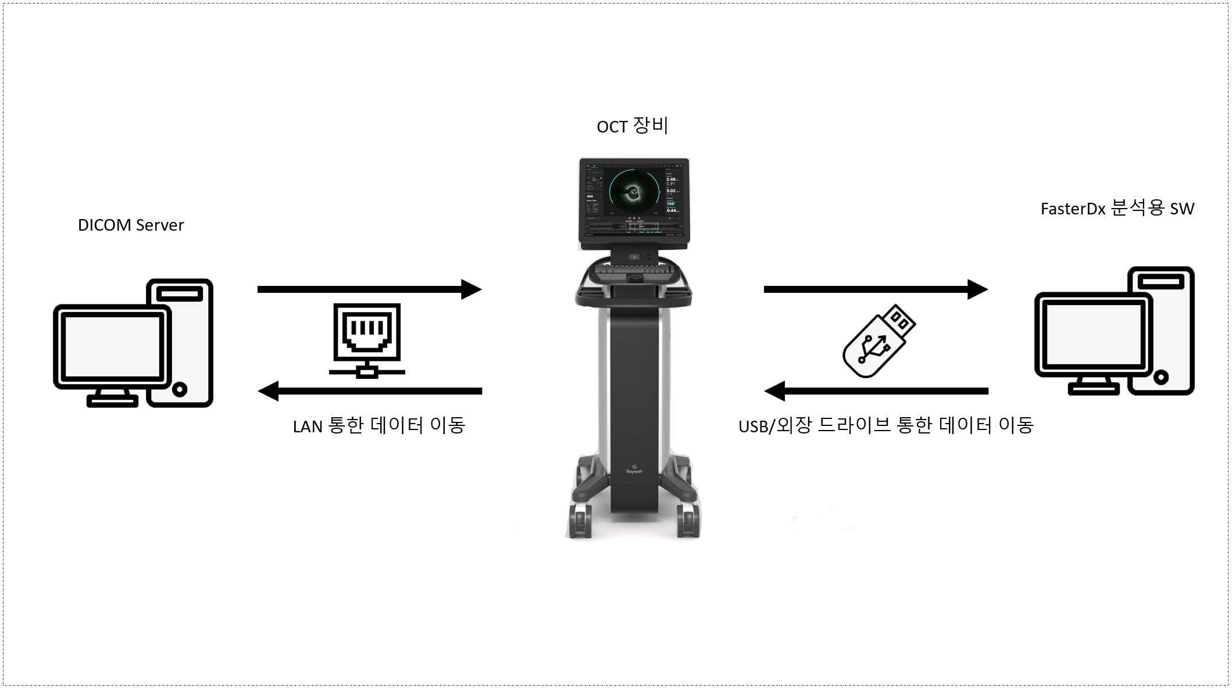
DICOM Server 와 LAN을 통한 연결은 TLS 1.3 사용

4.4 Data Flow Architecture
Illustrate how data flows between different components of the device system, including:
- Data input and output points
- Data storage and retrieval mechanisms
- Data integrity and encryption methods
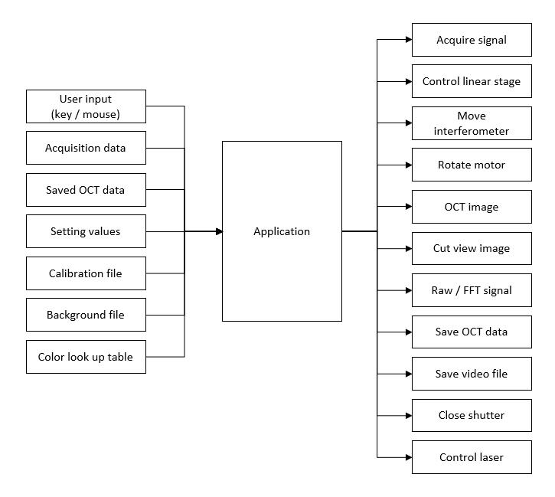

5. Security Mechanisms and Controls
Describe the security mechanisms used to protect the device architecture, including:
- Access control and authentication mechanisms
- Secure boot and firmware integrity verification
- Logging and monitoring systems for anomaly detection
Windows 인증 사용
Windows AppLocker 를 사용해서 화이트리스트 실행 정책 적용 (비인가 소프트웨어 실행 방지)
Secure Boot 활성화 (부팅 시 악성코드 주입 방지)
Windows Defender 사용

6. Documentation
Provide documentation practices for maintaining architecture diagrams and security design records.

